Spectroview with Gausian Filter

When Scanning – After preparation the Data monitoring page will display.
Check the F0 option to assure that the water peak( Green peak) is at F0 (Red line)
If not you have probably positioned in fat, bone, orbits, air or water
If that occurs stop the exam and reposition
If ok Hide
Check the FWHM ( Full Width Half Maximum) under comments
The most recent reading with be at top of list
Note this number for post processing later.

RM on Spectroview sequence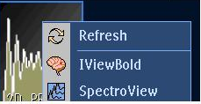

Choose Spectroview

Select Voxels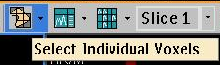

Edit Script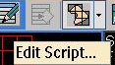

Select Apodization Filter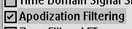

Use ½ the FWHM from Scanning for the Gausian Filter
- Note- If FWHM was 5 or lower skip this step
- If you do apply a Gausian filter then apply and Exponential filter of – ½ of the Gausian
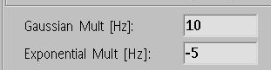
Run

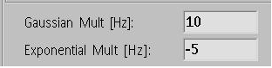
Select Script
Choose appropriate script
Long TE etc.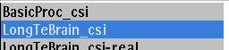

Select “No ON OPTION DO YOU WANT TO SAVE CURRENT CHANGES

THEN “RUN” SCRIPT

SELECT INDIVIDUAL VOXELS OR HOLD THE “CTL” OR “SHIFT” KEY TO SELECT MULTIPLE VOXELS

Note the ability to drag “Bold/Fmri” and/or “Fibertrak” overlays
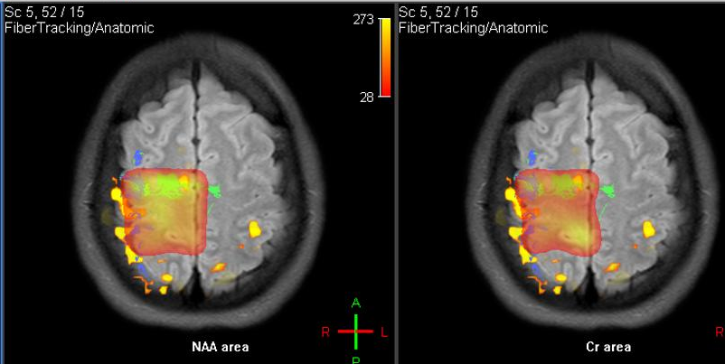

Note differences in with and without Gausian filter ( Same voxel with and without )

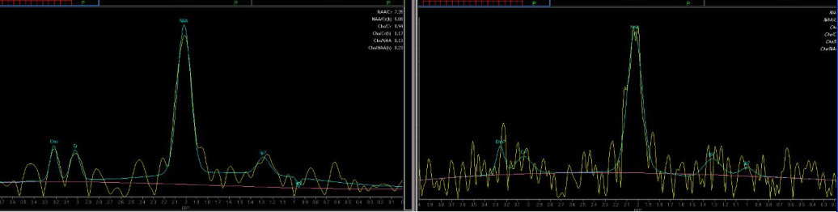

Note Right Mouse menu options on graphs
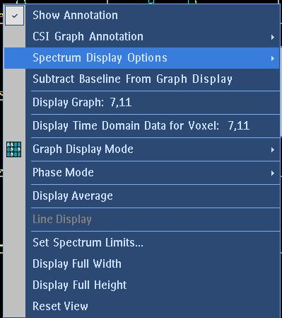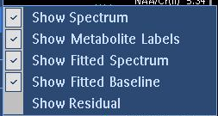

Note Right Mouse menu options on color maps

